**Lab Report 4.3**

**Date: 5th October 2021**

**Name: Rita Abani**

**Roll No: 19244**

**Title of Experiment: Objective 4.3: Study of Clipper and clamper circuit.**

**Brief Description:**

In this experiment, we simulated a circuit in LTSpice to depict the output waveforms of the clipper and clamper circuits . Clipping circuits are used to remove a part of a signal which is above or below a reference level. A clamper circuit, on the other hand, shifts a signal to a defined value. Basically, this circuit adds a DC component to the input signal. Clipping circuits are also known as limiters, amplitude selectors, or slicers. Half-wave rectifier is also a good basic example of clipper circuit where the reference level is zero and the signal below zero voltage (i.e. negative) are not allowed to pass through.

**Schematic diagram:**

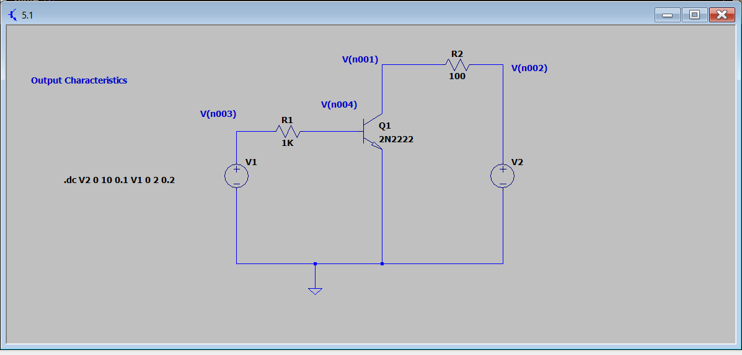

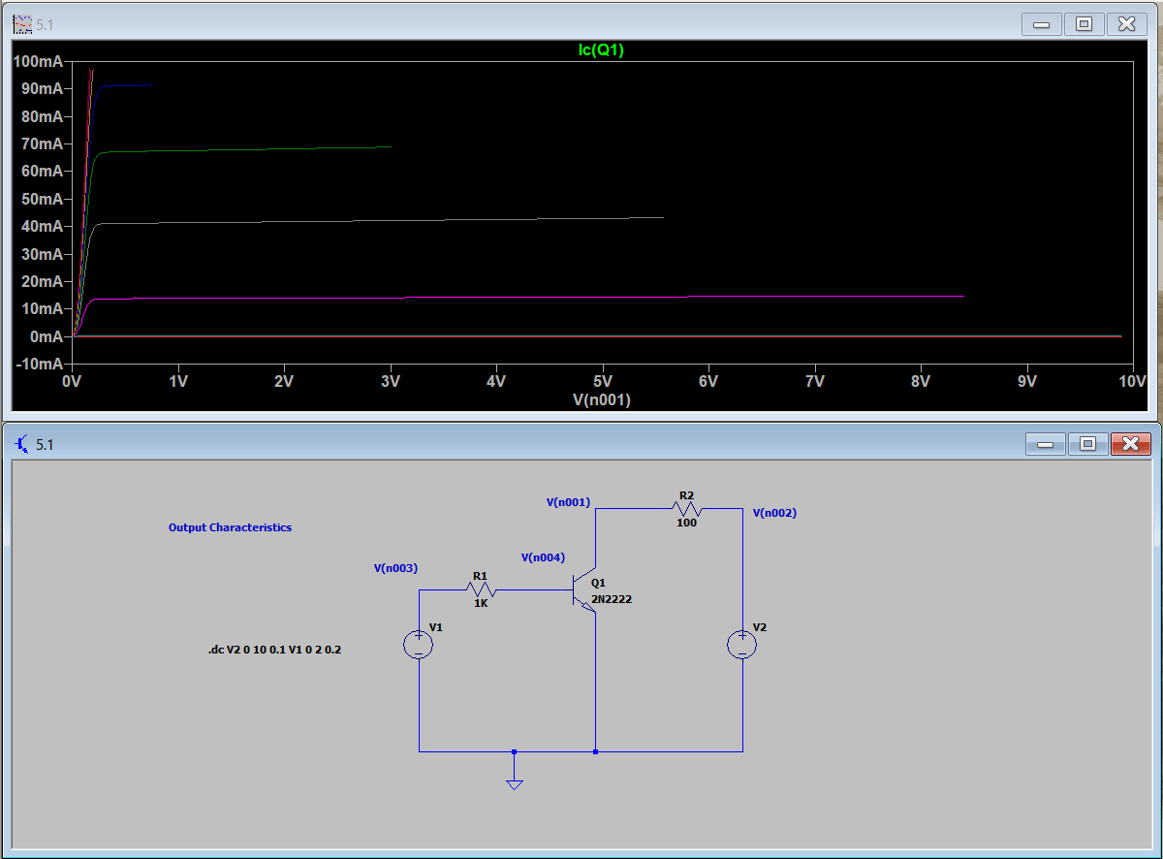

2)

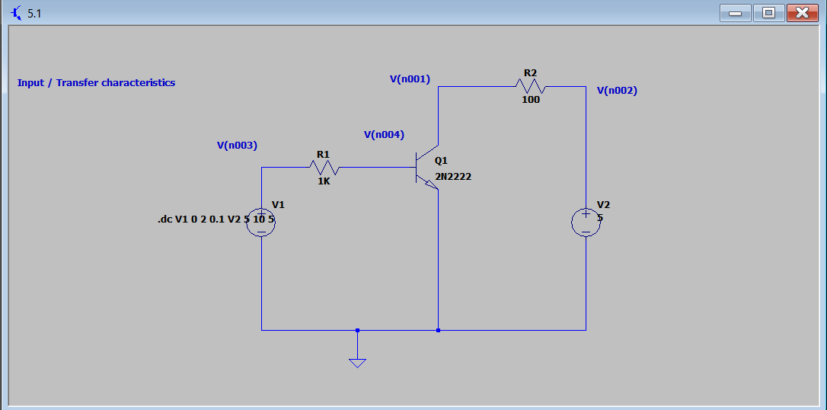

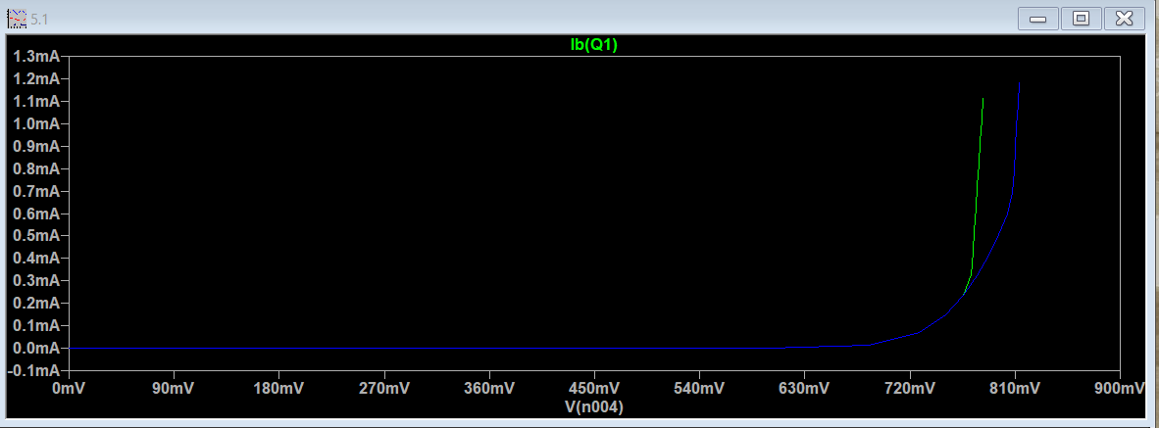

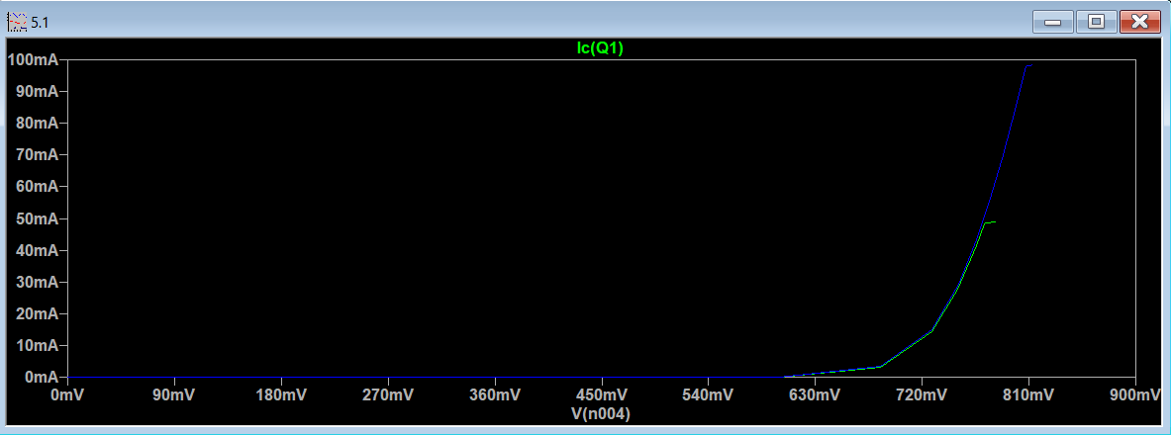

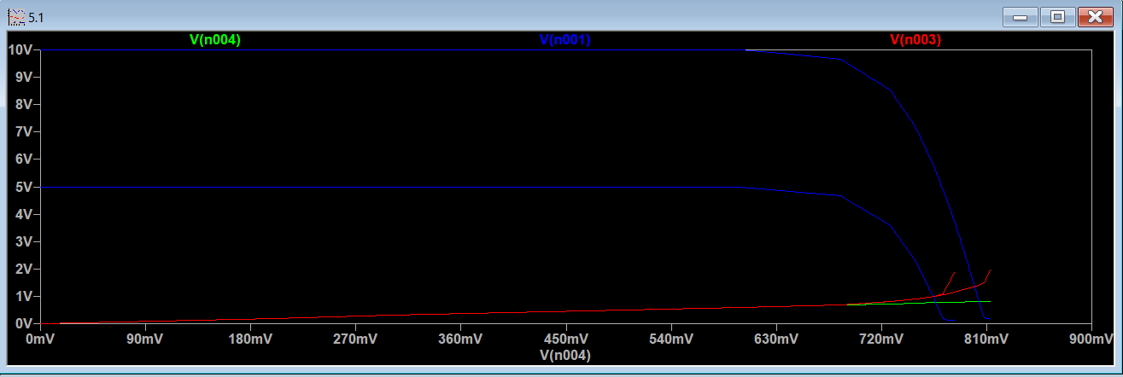

3)

